[DATE]

TO: All Residents

FROM: [NAME OF PROPERTY MANAGEMENT CO.]

RE: Laundry Room Upgrade to Mobile Pay

Good news! Our on-site washers and dryers will soon have a new laundry payment system. You will be able to use your phone to pay and start machines using WASH-Connect, a convenient mobile pay app that makes doing laundry a breeze. Once installed, the app will be the only payment method accepted in the laundry room.

**WASH-Connect Benefits**

* **PAY & START MACHINES** – Scan the QR Code on the machine or enter the machine number to pay for wash and dry cycles.
* **CHECK MACHINE STATUS –** Use the app to view machine availability from inside the laundry room.
* **CYCLE TIMER COUNTDOWN –** Get real-time alerts and notifications to monitor cycle progress and completion.
* **REFUNDS –** Access your recent transactions and request a refund instantly.
* **RESOURCES & SUPPORT –** Report out-of-order machines, request a refund and access helpful resources using the app.

Scan the code to install the free WASH-Connect app on your phone now!

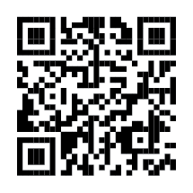

Please see the attached instructional flyer to learn more about WASH-Connect. If you have questions, please contact [mobilesupport@washlaundry.com](mailto:mobilesupport@washlaundry.com).

Happy washing!

[NAME]

[TITLE]