[DATE]

TO: All Residents

FROM: [NAME OF PROPERTY MANAGEMENT CO.]

RE: Laundry Room Upgrade to Mobile Pay & Credit/Debit Card Readers

Good news! Our on-site washers and dryers will soon offer two new laundry payment methods. You will be able to use your phone to pay and start machines using 1) WASH-Connect, a convenient mobile pay app that makes doing laundry a breeze, or 2) Pay with any major credit or debit card using the card reader on the machine. Once installed, these will be the only payment methods accepted in the laundry room.

WASH-Connect Benefits

- PAY & START MACHINES – Scan the QR Code on the machine or enter the machine number to pay for wash and dry cycles.

- CHECK MACHINE STATUS – Use the app to view machine availability from inside the laundry room.

- CYCLE TIMER COUNTDOWN – Get real-time alerts and notifications to monitor cycle progress and completion.

- REFUNDS – Access your recent transactions and request a refund instantly.

- RESOURCES & SUPPORT – Report out-of-order machines, request a refund and access helpful resources using the app.

Scan the code to install the free WASH-Connect on your phone now!


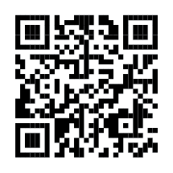

Please see the attached instruction flyer to learn more about WASH-Connect and credit/debit card readers. If you have questions, please contact mobilesupport@washlaundry.com.

Happy washing!

[NAME]
[TITLE]

